H.T No
Regulations:
A17

Sreenidhi Institute of Science and Technology
(An Autonomous Institution)
Code No: 6AC07 Date: 03-Sept-2021 (FN)

B.Tech IV-Year I- Semester External Examination, Aug/Sept - 2021 (Supplementary) CONTROL SYSTEMS (ECE)

Time: 3 Hours Max.Marks:75

Note: a) No additional answer sheets will be provided.
b) All sub-parts of a question must be answered at one place only, otherwise it will not be valued.
c) Missing data can be assumed suitably.

ANSWER ANY 5 OUT OF 8 QUESTIONS. EACH QUESTION CARRIES 15 MARKS.

Bloom's Cognitive Levels of Learning (BCLL)

Remember | L1 | Apply | L3 | Evaluate | L5
Understand | L2 | Analyze | L4 | Create | L6

 |  |  | BCLL | CO(s) | Marks
1. | a) | Determine overall transfer function gain C/R for the block diagram given below by reduction technique.  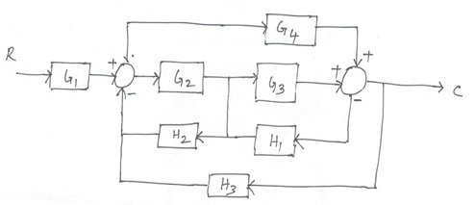 | L5 | CO1 | [8M]
 | b) | Write the masons gain formula and determine overall gain C/R by constructing signal flow graph for the block diagram given in question no.1 (a). | L5 | CO1 | [7M]
2. | a) | Write the standard test input signals that are used for various types of systems. Explain the time response of first-order system with step input signal. | L2 | CO2 | [8M]
 | b) | The open loop transfer function of a unity feedback control system is  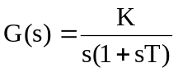  by what factor, the gain K should be changed so that the damping ratio is increased from 0.4 to 0.8. | L5 | CO2 | [7M]
3. | a) | The closed loop transfer function of an antenna control system is given by  T(s) = 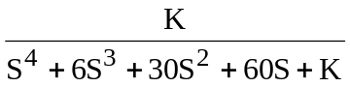  Determine the range in which ‘K’ must lie for the system to be stable. | L5 | CO3 | [8M]
 | b) | Draw the root locus of unity feedback control system whose open loop transfer function is  G(s) = 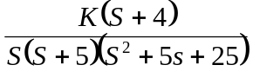 | L5 | CO3 | [7M]
4. | a) | Sketch the bode plot for the open loop transfer function of a unity feedback system G(s) = 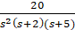  Determine the value of K for the system to be stable. | L5 | CO4 | [8M]
 | b) | Draw the Bode plot of the system whose open loop transfer function is given by  G(s) H(s) = 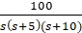.  Determine the gain margin and phase margin from the plot. | L5 | CO4 | [7M]
5. | a) | Sketch the Nyquist plot for a system with open loop transfer function  G(s) = 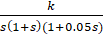 Comment on its stability. | L5 | CO5 | [8M]
 | b) | Explain the necessity of compensation and types compensation schemes. Briefly explain the lag, lead and lead-lag compensators. | L2 | CO5 | [7M]
6. | a) | Obtain the time response of the system represented as state model  [] =Ax+Bu:[y] =Cx:  Where A= 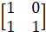 ; B = ; C=  U = unit step function; Initial state vector X(0) = | L5 | CO6 | [8M]
 | b) | Given the system in the state variable X= AX+BU  Where A = 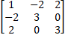 ; B =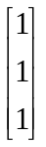  Transform the system to diagonal form. | L5 | CO6 | [7M]
7. | a) | Determine transfer function of synchro transmitter and receiver pair. | L3 | CO1 | [5M]
 | b) | Write time domain specifications. | L2 | CO2 | [5M]
 | c) | Explain R-H criterion for assessing the stability of systems. | L3 | CO3 | [5M]
8. | a) | Write the co-relation between time and frequency response. | L2 | CO4 | [5M]
 | b) | Explain the construction of polar plots and from the plots determine the procedure to obtain gain and phase margin. | L4 | CO5 | [5M]
 | c) | Significance of STM .and write the difference between state variables and physical variables. | L2 | CO6 | [5M]

-- 00 -- 00 –

